From the Marketing desk….
Hey! Mr. Marketing Man, what have you been up to?
At the end of June, I attended BA World and Project Summit in Melbourne and BA World in Sydney. Both conferences whilst primarily aimed at Business Analyst were very much attended by Project Managers, Project Coordinators and BA’s. The conference if you missed it was a great example at how complimentary the two skills are in any project or corporate activity. Track sessions were vast with many specifically touching on topics of Project Management and the many skills that make the art of managing projects successful. Attendees had the opportunity to participate and network with a line-up of expert speakers delivering insightful, practical and tangible information via track sessions, case studies and roundtable discussions.
As destiny would have it, and to show us all how closely we must work together, I was one of the lucky winners in a draw for a copy of the Business Analyst Body of Knowledge (BABoK).
The BABOK was first published by the International Institute of Business Analysis (IIBA) as a draft document in October 2005, for consultation with the wider business analysis and project management community, to document and standardise generally accepted business analysis practices. The first formal release was at version 1.6 in June 2006. Version 2.0 was released 31 March 2009, Version 3 is scheduled for release this year.
The BABOK just like our PMBoK is defined and updated by the professionals who use it every day and is continuously under active review and consultation. Gus Sabatino PMI Marketing Director
and IIBA President Tim Coventry (Centre)

At BA World Sydney our Chapter hosted a booth where we promoted not only PMI but the National Conference in May 2013. I would like to thank Kate Morris (Events Director) and Maja Kowalski (Communications Director) for helping out during the two day event, and Julia Checchia (President) for her support.

What? You’ve not heard of the 2013 PMI National Conference - Australia titled 21st Century Leadership?
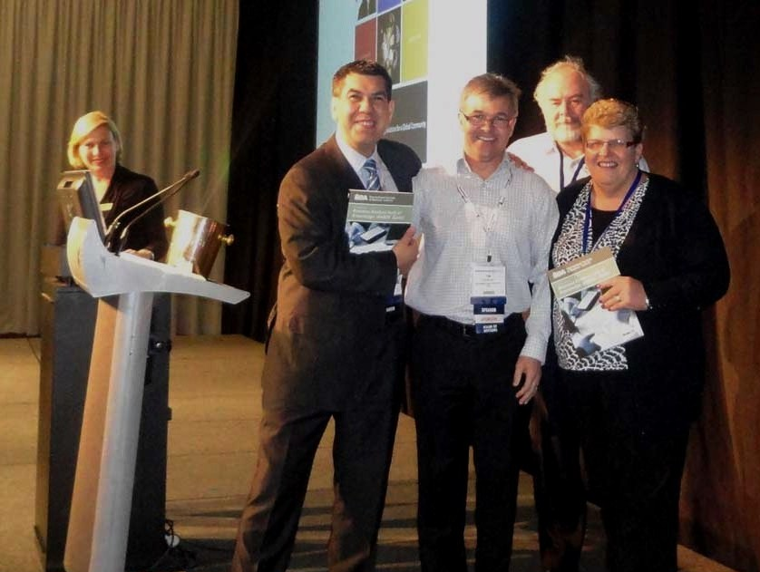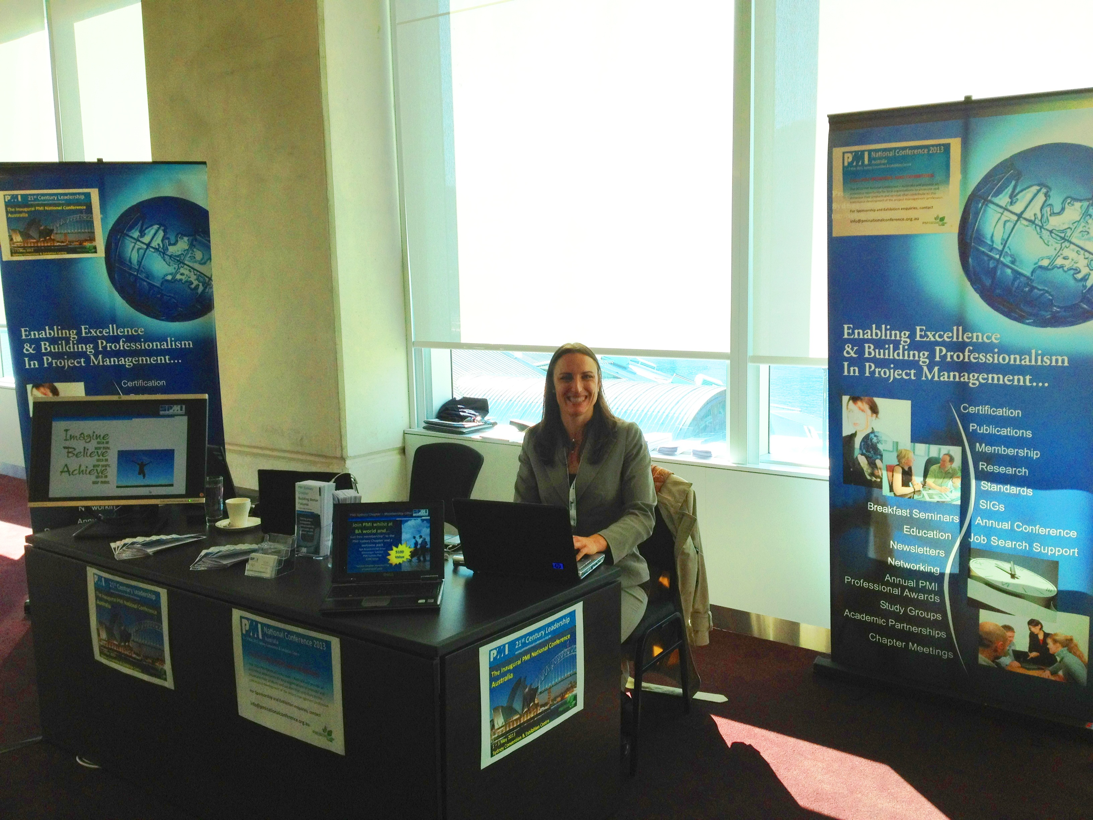This is one conference which your career cannot afford to miss! It will be held at the Convention Center in Sydney during the 1st – 3rd of May 2013.
The conference will be a platform for Professionals, Academics and Community representatives to share Knowledge, Experience and Professional camaraderie; whilst recognising and acknowledging professional Excellence.
The Conference will also provide a great line up of master classes, thought provoking papers, interactive workshops and panel discussions by some great keynote speakers and presenters.

Pencil it in your calendar and start asking your organisation to support your attendance, your career will thank you, and so will your company on your return!
The Conference will provide an enormous opportunity for local organisations to promote and showcase their products and services that contribute to the continuous development of the project management profession.
For Sponsorship and Exhibition enquiries, contact info@pminationalconference.org.au

Can your business afford not to be represented at the 2013 PMI National Conference?

Welcome to our new Sponsor
I continue to meet with educational, professional and corporate organisations and the importance of the role we play in today’s business outcomes has never been so evident to me

I am incredibly excited to announce that Paxus has partnered with the PMI Sydney Chapter in Sponsorship.

Paxus has partnered with PMI from an educational perspective and is sponsoring our educational streams.

Leveraging more than 30 years of recruitment industry experience and knowledge, Paxus have developed and fine-tuned permanent and contractor recruitment methodologies. Together we will be expanding opportunities an skillsets to our Project Management Community

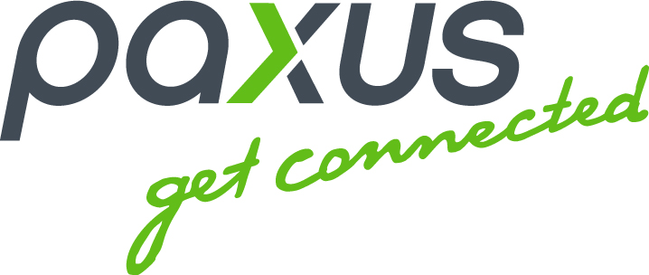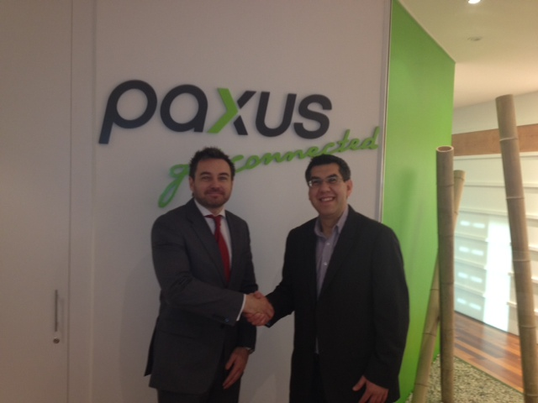You will now see the Paxus logo on our website and I encourage you to see what Paxus can offer you by clicking on the link in our website.

Until the next newsletter,
The Marketing Team,

marketing@pmisydney.org
For Sponsorship enquiries, contact Gus Sabatino on +61 410 699371

